The puzzle of a cross from Crayke

– by Maddy Pelling, research student, York

*University of York Partnership student Maddy Pelling examines fragments of a free standing Anglo-Saxon stone cross in the*[*Yorkshire Museum*](https://www.yorkshiremuseum.org.uk)*.*

<https://www.yorkmuseumstrust.org.uk/blog/the-puzzle-of-a-cross-from-crayke-maddy-pelling/>

This stone fragment was found in Crayke, North Yorkshire during an excavation in 1937 and dates from the mid to late 8th century. The settlement at Crayke appears in the Doomsday book, although there is evidence of the site being inhabited in the Anglian period and, perhaps, even earlier. The fragment forms the end of a cross arm and would have been part of a large free-standing cross.  The broad, angular end of the arm falls away to a shallow curvature as it nears the main shaft of the cross. Unfortunately, the main body of the sculpture has now been lost, although we may be able to guess at its shape, size and decoration based on the details of the fragment.

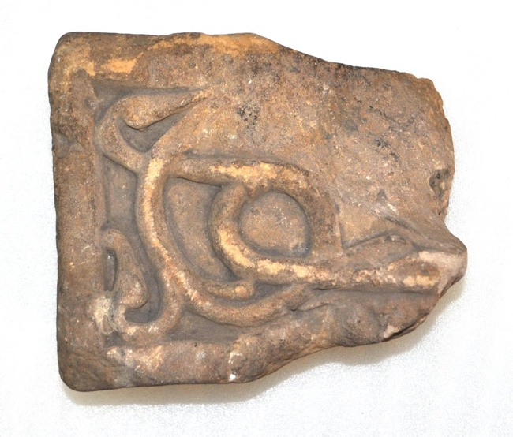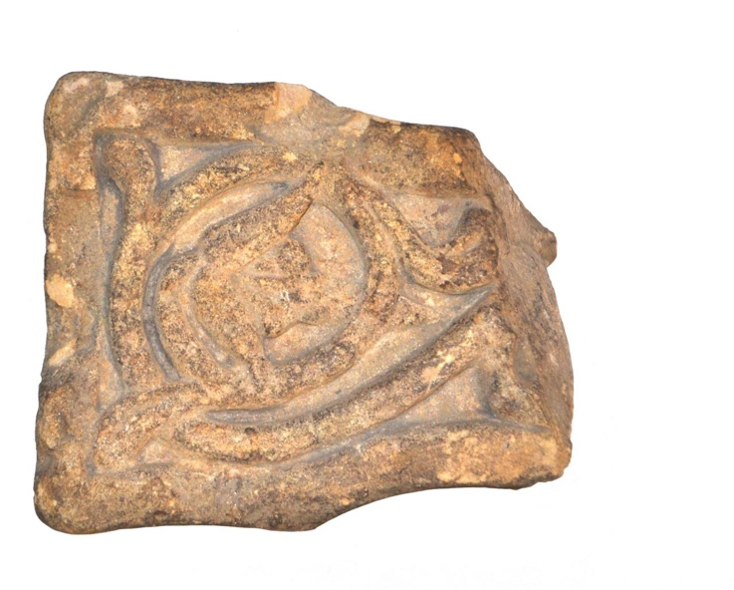

Framed with a thick, flat border running around the edges of the cross arm, the fragment displays a sophisticated form of vine scroll found on similar monuments of the period, including the Bewcastle Cross in Cumbria . The scroll curls inwards, terminating in a pendant leaf flower at the centre. Small stems split away from the main scroll and end in individual drop leaves that appear to break the boundaries of the frame and reach out. Stone sculpture was often used to capture the natural world and represent its close proximity within everyday experience.

A second part of the same cross adds a little more detail to this story. It has been suggested that the fragment marks the edges of a crucifixion scene. Crucifixion was a common motif in stone work of the Anglian period, particularly on free standing crosses, with artistic concerns mirroring the expanding power and influence of the Christian religion. Although it is difficult to decipher any clear details on the fragment to prove this theory, it is possible to interpret the detail in the top right corner of the fragment as an arm. The arm is ribbed with drapery and rests its hand on the outside edge of the vine scroll.

The deep groove carved into the surface of this detail may have been an attempt by the sculptor to indicate folded clothing. Certainly, it was common practice to combine different artistic elements such as plant scroll and animal motifs with Christian iconography in sculptures of this type, even mixing pagan and Christian decoration. Therefore, it is not too difficult to imagine our fragment as part of a larger cross on which the last moments of Christ’s life on earth, and the moment of his sacrifice, are intertwined with plant scroll signifying everlasting life and rebirth.

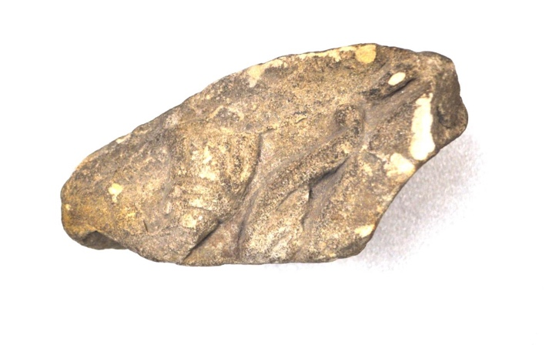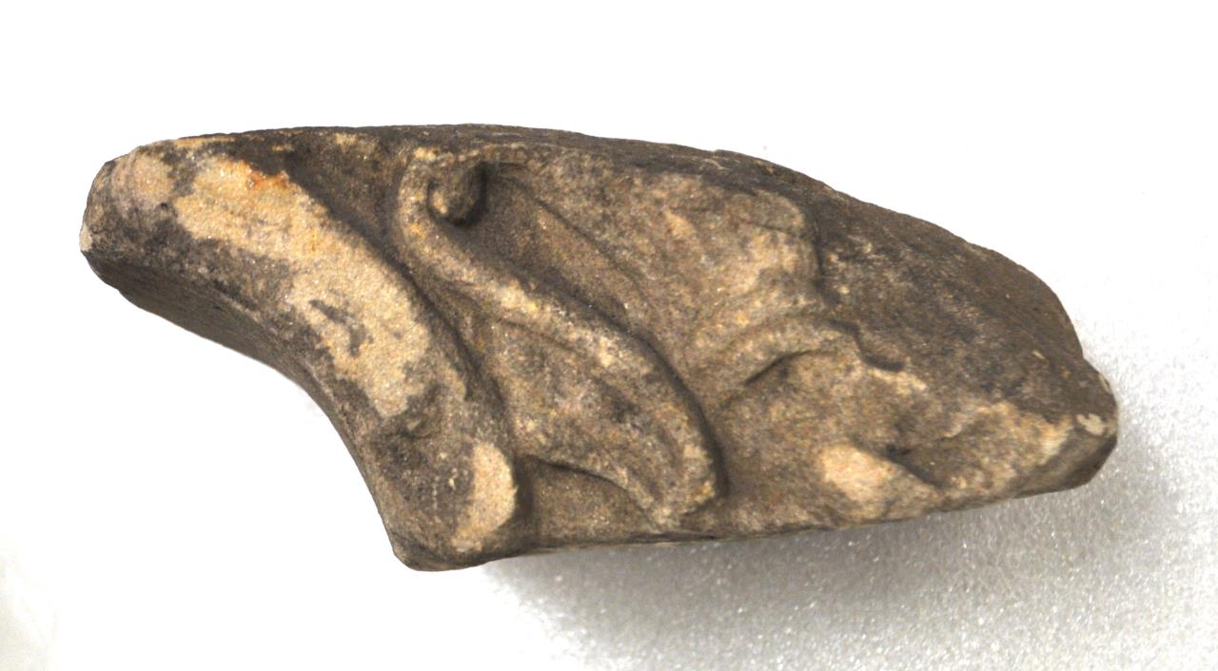

By the 8th century, Crayke is believed to have been the site of an important monastery. Echa of Crayke, a famous anchorite with the power to heal those in need, is mentioned in Alcuin’s York poem and is thought to have died in the monastery at Crayke in 767. As a contemporary to our stone fragment, he may have been familiar with the sculpture. Free-standing stone crosses during this period were public monuments around which devotional worship would have occurred, and so a sculpture of this sort would have been a common part of daily life for any monk living at this site.

Over a century before our stone was sculpted, King Egfrid had granted Crayke to the diocese of Durham. Close to York, it provided shelter and safety to the monks travelling from Lindisfarne and formed part of a religious route from York, the capital in the North and the religious centres surrounding it. It helped to link the remote and isolated religious communities of Northumbria with the city and allowed the two worlds to interact in terms of trade, conversation and learning. This fragment gives us a small insight into what the settlement at Crayke was like as well as an idea of the population and concerns of the wider landscape around York.